Defect (Bug) Report

**Title:** English Stories- Mobile Application does not Autorotate

**Date:** 30/06/2021

**Device**: Infinix HOT 8 lite

**Os Version**: 8.1.0

**Screen Resolution**: 720 x 1600 px

**Project**: Books Offline Mobile Application

**Description:**

ID – 001

**Steps to Reproduce:**

1. Navigate to English Stores App
2. Click on auto-rotate on the mobile device
3. Observe the bug

**Screenshot:**

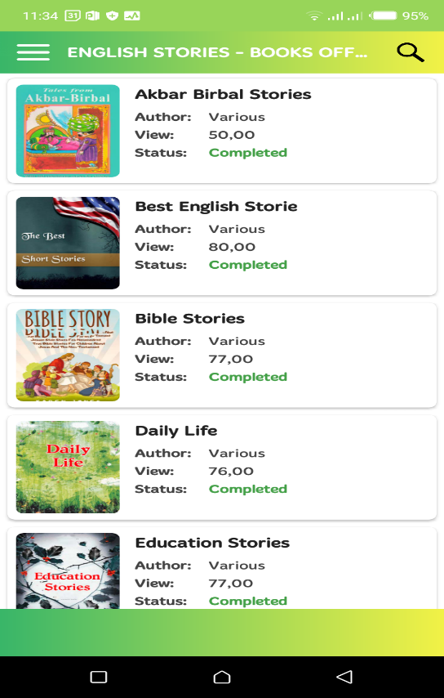

**Bug severity**: Medium

**Comment**: No comment

**Title:** English Stories- Mobile Application images does not Load fast

**Date:** 30/06/2021

**Device**: Infinix HOT 8 lite

**Os Version**: 8.1.0

**Screen Resolution**: 720 x 1600 px

**Project**: Books Offline Mobile Application

**Description:**

ID – 002

**Steps to Reproduce:**

1. Navigate to English Stores App
2. Scroll down through application
3. Observe the bug

**Screenshot:**

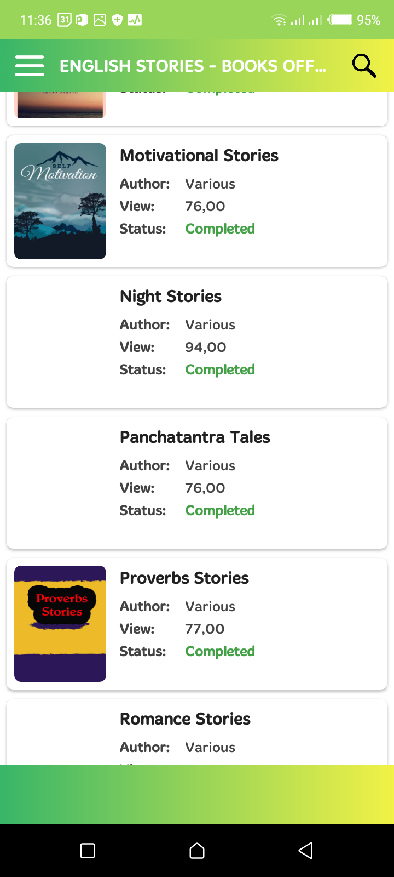

**Bug severity**: low

**Comment:** No comment